Iniboot instructions
Conditions for making a boot system：

1. Ubuntu18.04 or later, centos6 or later

For reference：

1、Disassemble the TNAS, and take out the boot system U disk from the TNAS motherboard (there may also be screws under the sticker)

2、Install VMware Workstation Pro on a Windows/Mac PC.

3、Install Ubuntu on VMware Workstation Pro.

4、Start the Ubuntu OS.

5、Insert the USB to Windows PC and connect the USB to the VM.

- Open the Ubuntu terminal.
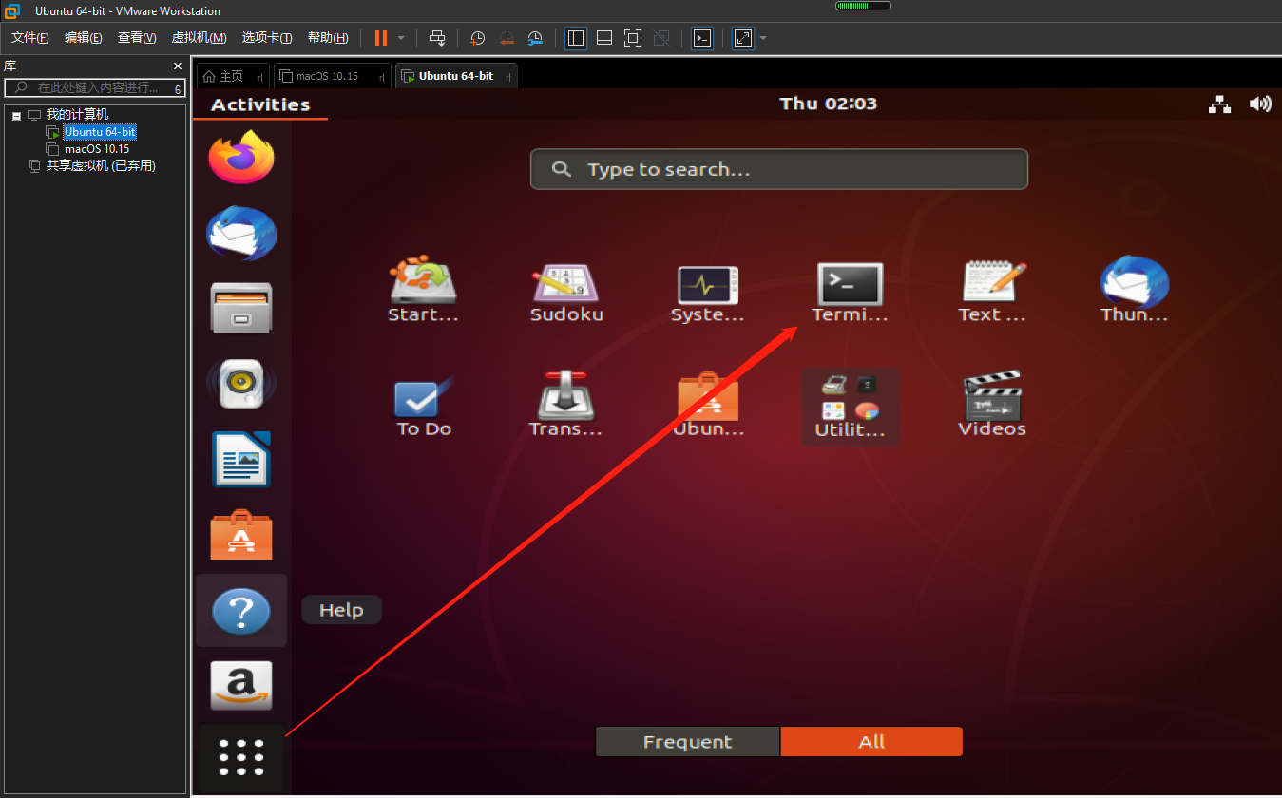

7、Enter “sudo -i”, and enter the password of the current user to switch to root. (the password will not be displayed when you enter the password) 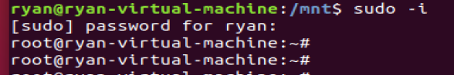

8、enter “cd /mnt/” to go to /mnt,
enter “wget https://download2.terra-master.com/bzImage.zip” to download the package.

9、After the download is complete, enter “ls” to check whether the compression package is successfully downloaded.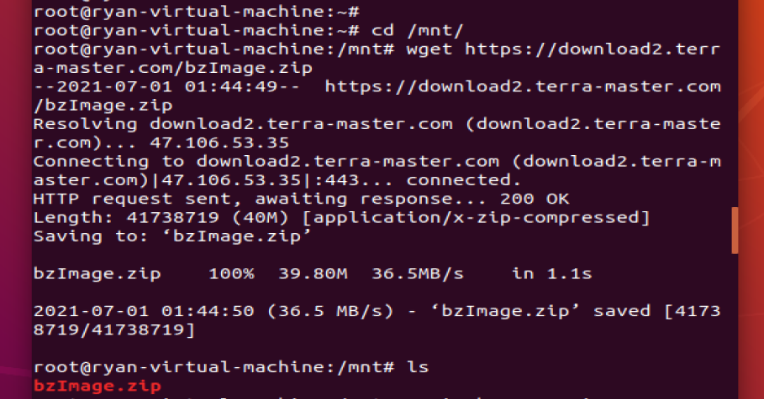

10、Enter ”unzip bzImage.zip” to unzip the package. Enter “ls” to check if there is the decompressed file.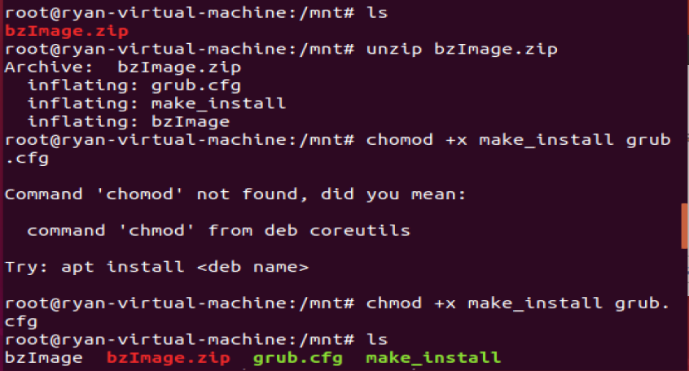

11、Enter “chmod + x make_install”,then enter “chmod +x grub.cfg”。Or you can enter “chmod +x make_install grub.cfg" to authorizes execution rights to users.
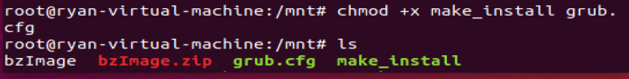

12、Enter “./make_install bzImage” to write file to USB.
