TerraMaster F4-425 Pro

3+4 Bay Hybrid Network Storage

Datasheet

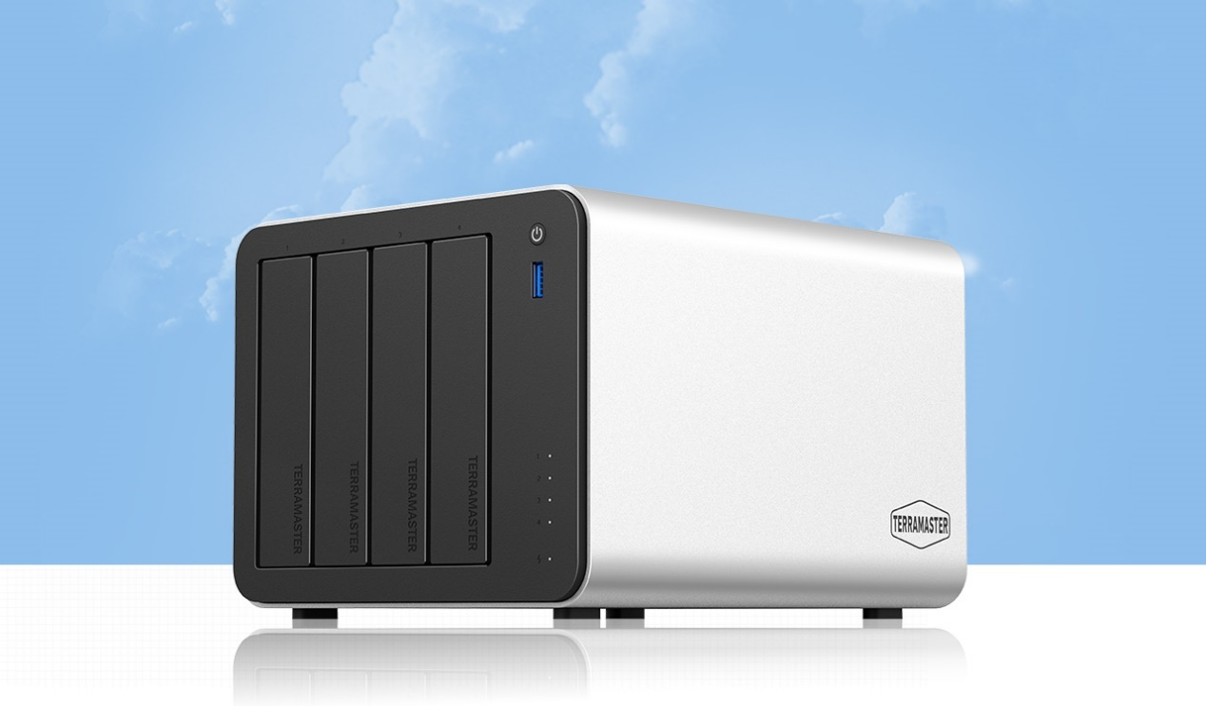
The TerraMaster F4-425 Pro is powered by TOS 7, the world’s first AI-native NAS operating system, and driven by the Intel N305 octa-core processor, delivering robust performance and significantly enhanced 8K transcoding capabilities. Featuring an innovative 4-bay design with three M.2 NVMe slots, the F4-425 Pro supports up to 144TB of total storage capacity. The system also supports local AI-powered photo classification, intelligently organizing photos without uploading data to the cloud for enhanced privacy protection. Built with multi-layer security protection and enterprise-grade backup solutions, the F4-425 Pro supports Docker virtualization, cross-platform cloud synchronization, and direct disk mounting. It also includes practical features such as home media streaming, automatic mobile photo backup, and high-speed remote access. Easy to deploy and intuitive to use, the F4-425 Pro is an all-in-one storage solution ideal for home data centers and small to medium-sized business environments.
The World’s First AI-Native NAS Operating System, Ushering in a New Era of Intelligent Storage
TOS 7 is far more than a traditional NAS operating system enhanced with AI plugins—it represents a comprehensive transformation spanning system architecture, interaction experience, and ecosystem infrastructure. As the world’s first NAS operating system deeply optimized for AI-driven scenarios, TOS 7 fundamentally eliminates the complexity barriers traditionally associated with NAS platforms. Complex storage management, system configuration, and service deployment can now be accomplished effortlessly through natural language interaction, transforming NAS from a passive data repository into an intelligent and proactive digital assistant.

Underlying Architecture Innovation: A Technical Foundation Tailor-Made for AI
Built around an AI-native design philosophy, TOS 7 introduces extensive restructuring and deep optimization at the system core. Through standardized and intelligent enhancements across the entire interface framework, TOS 7 establishes a robust technical foundation designed specifically for efficient intelligent agent execution. Combined with AI-optimized toolkits and distributed scheduling capabilities, intelligent agents can seamlessly access and orchestrate full system functionality without requiring additional integration or customization. This architecture fundamentally resolves the long-standing integration challenges between traditional NAS systems and AI-driven workflows, enabling highly efficient and precise task execution across complex operational scenarios.

User Interaction Redefined: Natural Language Enables Effortless Operation
TOS 7 completely redefines the complex operational logic of traditional NAS, placing natural language interaction at its core to create an intelligent experience accessible to everyone. The system natively integrates core intelligent agent components, enabling full-feature AI interaction without additional deployment. Users can issue natural language commands via text or voice to accomplish over 90% of NAS operations. It also supports natural language-based scheduled tasks, conditional automation, and batch operations, complemented by seamless multi-device collaboration, allowing users to easily control their NAS from anywhere — breaking both operational and spatial limitations.

Empowering the Developer Ecosystem: A Unified Platform for AI Application Innovation
TOS 7 is committed to building an open and mutually beneficial AI developer ecosystem. To support this vision, we are launching a brand-new developer platform that provides comprehensive end-to-end development services, including documentation resources, development tools, testing environments, and deployment management. The platform integrates a rich portfolio of self-developed AI capability modules that developers can directly reuse, customize, or extend, significantly lowering the barrier to AI innovation. At the same time, TOS 7 establishes a comprehensive ecosystem collaboration framework that supports third-party intelligent agent integration and skill publishing, forming a complete “development–testing–distribution” lifecycle that enables developers to rapidly build and deploy AI applications.

End-to-End Scenario Coverage: AI Empowers the Entire Storage Lifecycle
The AI capabilities of TOS 7 extend across every NAS workflow, delivering intelligent enhancements across the entire storage lifecycle—from system management to service deployment. Whether handling storage management, network configuration, application deployment, media processing, backup, or recovery, TOS 7 leverages AI-driven automation to optimize operational efficiency and simplify complex workflows. The system can intelligently interpret complex instructions, coordinate multiple subsystems autonomously, and complete tasks with minimal manual intervention, enabling a truly hands-free management experience. Compared with the limited AI functionality offered by conventional NAS platforms, TOS 7 establishes a new benchmark for intelligent storage systems.

Powerful Hardware Configuration
Powered by Intel’s latest N305 processor with 8 cores and 8 threads, turbo frequencies up to 3.8 GHz, and integrated Intel® Graphics, delivering up to 25% faster 8K video transcoding. Supports AES-NI hardware encryption, paired with 8GB memory, dual 5GbE network interfaces, and three M.2 slots.

Innovative Triple M.2 Design
The F4-425 Pro offers exceptional storage expandability: it supports up to four HDDs with a maximum capacity of 30TB per drive, and comes equipped with three M.2 SSD slots, each supporting up to 8TB. In total, the system can reach an impressive 144TB of storage.
For data protection, the three M.2 SSD slots can be flexibly configured. The three M.2 slots can be configured as a RAID 5 array for enhanced data security and high-speed storage, improving read/write performance. In addition, the system allows independent creation of storage spaces for HDDs and M.2 SSDs, accommodating a wide range of storage requirements.
When connected to a TerraMaster USB DAS array, the F4-425 Pro also supports creating separate storage pools and volumes on external drives. This provides scalable and efficient expansion options, offering users a flexible solution for growing storage needs.

Dual 5GbE Ports, High-Speed Performance
The F4-425 Pro is equipped with dual 5GbE Ethernet Ports, supporting multiple bonding modes for versatile applications. In real-world environments, combined with SMB Multichannel, it delivers linear write speeds of up to 1010 MB/s and achieves 4K random read/write performance of 280 MB/s, ideal for multi-user offices or video editing scenarios.

Localized AI, No Cloud Upload Required
TNAS uses on-device AI algorithms, so your photos never need to be uploaded to the cloud. This ensures secure, private, and intelligent management of your photo collection. With advanced face recognition, TNAS can automatically organize images into dedicated albums for different people, let you tag relationships, and even set custom album covers.
It also classifies pets, objects, and scenes, making it easy to find and share your photos. TNAS is an ideal photo management solution for families and photography enthusiasts alike.

Unified Family Album Management
Centrally store and manage all family photos, keeping your shared memories organized and secure. AI compiles individual photo collections from thousands of images effortlessly.
With timeline-based browsing, you can quickly locate your baby’s daily photos and videos, and cherish every moment of growth together with your loved ones.

Centralized Family Photo Management
Store and manage all family photos in one place, preserving shared memories. AI compiles individual photo collections from thousands of images effortlessly. The timeline feature helps quickly locate daily photos/videos of your child, allowing the family to cherish every growth milestone together.

TNAS Mobile – Everything Under Control
The all-new TNAS Mobile is simple and easy to use. It can automatically back up your phone’s photos and videos, while AI-powered photo management keeps even large collections organized and easy to browse.
With TNAS Mobile, you can set up and manage your TNAS device directly from your phone. The app integrates user management, storage management, personal folders, team-shared files, and a secure vault, providing convenient remote access, mobile office, and device management.
Sharing your precious memories has never been easier. TNAS Mobile offers detailed sharing controls, allowing you to set link expiration, access limits, validity period, encryption, and download permissions. Multiple security settings ensure your photo sharing is both convenient and safe.

Fast and Stable Remote Access
Even when your NAS is halfway across the world, your data is always within reach, allowing you to access the files you need anytime, anywhere.
Leveraging a globally distributed multi-node network, TNAS ensures stable data transmission. In any network environment, you can enjoy fast and reliable access to your NAS without any complicated setup.

Private and Secure Personal Cloud
The F4-425 Plus lets you easily set up a high-security personal cloud with just one click, without the need for subscription services.
Enjoy lightning-fast transfers powered by TPT direct connection technology, ensuring full-bandwidth performance.
Access your files effortlessly with zero technical barriers—no complicated setup required, and securely reach your data anytime, anywhere from smart devices.
Enterprise-grade privacy protection keeps your data fully secure, giving you peace of mind for all your personal information.

Unified Management of Massive Resources
Centralize all your data—scattered across Windows PCs, Macs, mobile devices, external drives, and cloud storage—into TNAS for unified management. This helps prevent data loss caused by hardware failures, ransomware, or other unexpected issues.

Family Data Storage Hub
The F4-425 Pro is a dedicated data storage and backup solution designed for households. Supporting hard drives up to 30TB each, it delivers a maximum total capacity of 120TB—enough to store:
• 30 million high-resolution photos
• 120 million work documents
• 80,000 HD movies
• 4 million lossless music tracks

Direct Mount for Data Drives
Unlike traditional NAS systems that require hard drives to be partitioned and formatted before installation—forcing users to erase existing data—the TOS 6 system introduces Direct Mount for Data Drives, a convenient feature that simplifies storage expansion.
With this capability, users can directly hot-swap a pre-used hard drive (with existing data) into their TNAS device and access its contents directly—no reformatting, no data loss.

Build Your Home Multimedia Hub
The F4-425 Pro boasts powerful 4K video hardware decoding capabilities. Compatible with media server applications used by hundreds of millions of people, such as Plex, Emby, and Jellyfin. It can stream video content to various devices—including smartphones, tablets, Roku, Apple TV, Google Chromecast, Amazon Fire TV, and smart TVs—allowing you to manage and enjoy a rich and diverse collection of movies and TV shows.

Video Resource Downloading
TerraMaster provides professional media download tools including Aria2, qBittorrent, Transmission and Xunlei—the F4-425 Pro delivers blazing-fast download speeds and efficient file transfer management for all your media content.

Seamless Cloud Drive Integration
With TerraMaster CloudSync, effortlessly connect your cloud storage to NAS for seamless synchronization and sharing. CloudSync combines support for multiple mainstream cloud services—including Google Drive, OneDrive, Amazon S3, Dropbox, Baidu Cloud, and Alibaba Cloud. Supports multiple sync strategies, data encryption, scheduled tasks, idle-time syncing, speed and bandwidth limits, and sync history tracking.

Permission Management
TNAS offers 13 customizable permission levels, allowing you to create individual user accounts for each family member or employee. Key features include bulk user and group creation, password complexity enforcement, and a recycle bin accessible only to administrators.
Seamless TNAS Integration with Windows Domain or LDAP
Once connected to a Windows Domain or LDAP, users can log in directly with their existing domain credentials—no separate passwords needed—greatly reducing IT maintenance costs.

Team Collaboration, Redefined
An enterprise-grade NAS solution designed for small and medium-sized businesses. With on-premises data storage, your files are fully protected to ensure maximum privacy and security. Powered by LAN-based ultra-fast access, you’ll experience seamless file sharing without bandwidth limits — delivering stable and efficient collaboration across your team.
Effortless PC Storage Expansion
Instantly extend your computer’s storage by mapping TNAS space as a native local drive. Enjoy the same smooth experience as using a local disk — with no compromises in speed, stability, or usability.
Flexible Access Control
Administrators can assign differentiated read and write permissions to folders based on user roles and specific needs, ensuring both data security and efficient management.
Team Shared Folders
Enable team members to quickly share and transfer files, improving collaboration efficiency and keeping workflows smooth.
Recycle Bin Permission Management
Files deleted by regular users are automatically moved to the recycle bin, but only administrators have full control—able to restore or permanently remove files as needed.
Guest Access Mode
Visitors can access authorized shared content without the need for an account or password. This simplifies temporary collaboration while maintaining data security.
Familiar Windows Experience
The system fully inherits the operational logic of the Windows file system, allowing users to work without adapting to a new platform and helping organizations reduce training costs.
Remote Access
When traveling or away from the office, employees can securely access the company’s internal file repository via the internet, ensuring important documents are always within reach.

Enterprise Backup Solution
BBS (Business Backup Suite) is TerraMaster’s self-developed, all-scenario enterprise backup solution. Its core components include TerraSync (TS), Centralized Backup (CB), Duple Backup (DB), CloudSync, and Snapshot.
TerraSync (TS): Enables data synchronization between multiple backup servers, as well as between backup servers and PCs.
Centralized Backup (CB): Consolidates data from employee PCs, file servers, and virtual machines within the enterprise, backing it up to a local TerraMaster backup server.
Duple Backup (DB): Provides remote disaster recovery by enabling backup replication between TerraMaster servers.
CloudSync: Supports cloud-based disaster recovery.
Snapshot: Offers file system and folder snapshots and recovery, helping safeguard against ransomware attacks.

Cross-Platform File Services
Supporting SMB, NFS, FTP/SFTP, AFP, iSCSI, and WebDAV protocols, it enables seamless file sharing across Windows, Mac, and Linux systems with granular user/group permissions and enterprise-grade security.

Applications for Small and Medium Businesses
With TNAS, you can easily deploy a wide range of services, including file servers, mail servers, web servers, FTP servers, MySQL databases, CRM systems, Node.js environments, and Java Virtual Machines. It is designed to meet the diverse needs of industries such as education, consulting, finance, research, legal services, and more.

Video Surveillance Management
TerraMaster's proprietary Surveillance Manager enables you to create a complete video surveillance system by connecting multiple ONVIF-compliant IP cameras to your TNAS. This integrated solution provides centralized camera management, live viewing, historical playback, and automatic storage of all recordings to designated TNAS locations - all through an intuitive unified interface.

User-Friendly NAS Operating System
The F4-425 Pro comes with TerraMaster’s 6th-generation NAS operating system (TOS 6), available completely free of charge. TOS is a web-based OS specifically designed for TerraMaster NAS devices, allowing all configurations to be done through an intuitive browser interface—no command-line knowledge required.
TOS 6 introduces over 40 brand-new features and brings improvements to more than 370 details, delivering a completely redesigned user experience from the inside out. With enhanced security mechanisms, your data is better protected than ever. Optimized system performance ensures faster task execution, providing TNAS users with an unmatched upgrade experience that is both powerful and easy to use.

Multiple Safeguards for File Security
In the face of increasingly sophisticated cyber threats, network device security now confronts unprecedented challenges. TOS delivers multi-layered defense mechanisms to safeguard critical data, significantly reducing risks from hackers and ransomware attacks.
1. System-Wide PAM Authentication
Enables flexible and configurable security policies across the system.
2. Firewall and Whitelist Rules
Restrict access by IP address, subnet, and port.
3. Encrypted Data Transmission
Secures data with 256-bit encryption and TLS protocols.
4. OTP Two-Factor Authentication
Adds mobile verification for login, enhancing account security.
5. IP Blocking
Automatically locks out addresses after multiple failed login attempts.
6. DoS Protection
Maintains TNAS stability during denial-of-service attacks.
7. Certificate Services
Ensures device authentication and encrypted access.
8. Security and Privacy Control (SPC)
Blocks unauthorized apps from accessing network and storage.
9. Secure Isolation Mode
Disables internet access to prevent attacks and unauthorized software, creating a safer environment.
10. TRAID Elastic Array
Provides flexible array configurations with online migration, expansion, and redundancy, improving disk space utilization.
11. TFSS File System Snapshots
One-click global snapshots and restoration of storage space, effectively helping to prevent ransomware attacks.
12. TFM Backup
Supports local and remote folder mirroring and incremental backups, optimizing storage usage.
13. HyperLock-WORM
Prevents tampering with data, with protection periods of up to 70 years.
14. Snapshots
Supports snapshots and restoration of files and iSCSI LUNs, with remote replication capability.

Docker Unleashes More Possibilities
Efficient Containerization: TOS works seamlessly with Docker Compose and Portainer, making it easy to deploy thousands of containerized applications and quickly meet personalized requirements.
Flexible Virtualization: Run multiple virtual machines in parallel with VirtualBox, and freely build testing, office, or lab environments.
With just one NAS, you can support diverse scenarios for work, study, and entertainment—unlocking new possibilities for your digital life and creative projects.

Panel Illustration:
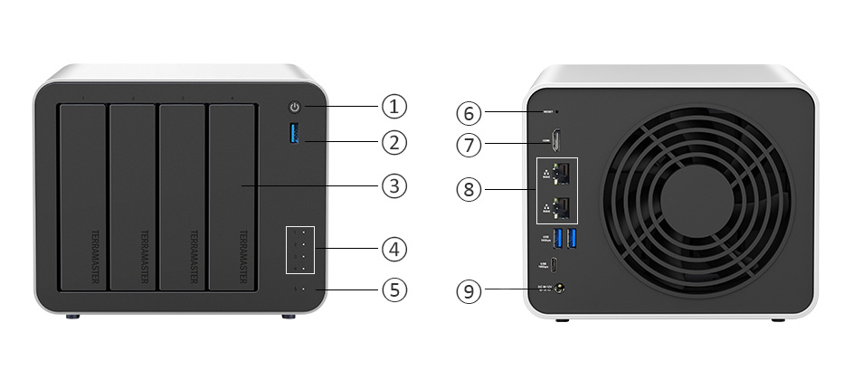
SN | Item | Description
 | Power button | Used to turn the device on/off
 | USB host | Use to connect USB storage device or USB wireless adaptor
 | Hard drive tray | Used for installing and securing hard drives
 | Hard drive indicator | Green: Normal operation status  Green (flickering): Reading/writing data  Off: No hard drive detected
 | Power indicator | Steady on: Power on  Off: Power off

Rear Cover Illustration:
SN | Item | Description
 | Reset Button | When the device is powered off, use a pin to continuously press and hold the RESET button on the back of the product. While keeping the RESET button pressed, briefly press the power button to start the device. Wait for approximately 30 seconds until you hear three consecutive "beep beep beep" sounds, then release the pin. Next, use the TNAS PC client software to perform a new search for the TNAS device and follow the client's instructions to restart the TOS system initialization process.
 | HDMI interface | For displaying the software codes or commands, not for video playing.
 | Network interface | 5000M/2500M/1000M/100M bps network interface
⑨ | Power interface | DC 12V power input  NOTE: Do not use a third-party power adaptor.
Specifications:
Processor
Processor Model | Intel® N305
Processor Architecture | X.86 64-bit
Processor Frequency | Max burst up to 3.8 GHz
CPU Single-Core Score | /
Hardware Encryption Engine | √
Hardware Transcoding Engine | H.264, H.265, MPEG-4, VC-1; maximum resolution: 4K (4096 x 2160); maximum frame rate per second (FPS): 60
Memory
System Memory | 8 GB non-ECC SODIMM
Pre-installed Memory module | 8 GB non-ECC SODIMM (1x 8GB)
Total Memory Slot Number | 1 (SODIMM)
Maximum Supported Memory | 32 GB non-ECC SODIMM
Note | TerraMaster reserves the right to replace memory modules with the same or higher frequency based on supplier's product life cycle status. Rest assured that the compatibility and stability have been strictly verified with the same benchmark to ensure identical performance.
Storage
Disk Slot Number | 4
Compatible Drive types | 3.5" SATA HDD
Compatible Drive types | 2.5" SATA HDD
Compatible Drive types | 2.5" SATA SSD
Maximum Internal Raw Storage Capacity | 120 TB (30TB x4) (Capacity may vary by RAID types)
M.2 2280 NVMe Slot | 3 (PCIe 3.0 x1)
Drive Hot Swap | √
Note | . Hard drive vendors will release their latest models of hard drives, and Maximum internal raw storage capacity may be adjusted accordingly.  . The maximum single volume size is not directly related to the maximum raw capacity.
File System
Internal Drive | Btrfs, EXT4
External Drive | EXT3, EXT4, NTFS, FAT32, HFS+, BTRFS
External Ports
RJ-45 5GbE Network Jack | 2
USB3.2 Host Port Type A | 3(10Gbps)
USB3.2 Host Port Type C | 1(10Gbps)
HDMI | 1
Appearance
Size (H*W*D) | 150*181*219 mm
Packaging Size (H*W*D) | 186*277*277 mm
Weight | Net Weight: 2.9 Kg, Gross Weight: 4.1 Kg
Others
System Fan | 120 x 120 x 25mm 1PCS
Fan Mode | Smart, High speed, Middle speed, Low speed
Noise Level | 20.9 dB(A) （Using 4 SATA HDDs/SSDs in standby mode; Test environment noise: 17.3dB(A); Test distance: 1m）
Power Supply | 90 W
Redundancy Power Supply | /
AC Input Voltage | 100V - 240V AC
Current Frequency | 50/60 Hz, Single frequency
Power Consumption | 45.0 W(Fully loaded Seagate 4TB ST4000VN008 hard drive(s) in read/write state)
Power Consumption | 14.0 W (Fully loaded Seagate 4TB ST4000VN008 hard drive(s) in hibernation)
Limited warranty | 2 years
Certificate | FCC, CE, CCC, KC
Environment | RoHS, WEEE
Temperature
Working Temperature | 0°C ~ 40°C (32°F ~ 104°F)
Storage Temperature | -20°C ~ 60°C (-5°F ~ 140°F)
Relative Humidity | 5% ~ 95% RH
Package Contents
 | Host unit (x1)
 | Power cord (x1)
 | Power Adapter(x1)
 | RJ-45 network cable (x1)
 | Quick Installation Guide (x1)
 | Limited Warranty Note(x1)
 | Screws(a few)

TOS Features
OS Supported
Supported Client OS | Windows OS, Mac OS, Linux OS
Supported Web Browsers | Google Chrome 97.0.xxxx, Mozilla Firefox 9.3, Apple Safari 12.1; Microsoft Edge 99.0.xx or later version.
Supported mobile OS | iOS14.0, Android 10.0 or later version
Storage Management
Supported RAID Types | TRAID, Single, JBOD, RAID 0, RAID 1, RAID5, RAID 6, RAID 10
Maximum Internal Volume Number | 256
Maximum iSCSI Target | 128
Maximum iSCSI LUN | 256
Volume Expansion with Larger HDDs | TRIAD, RAID 1
Volume Expansion by Adding a HDD | /
RAID Migration | √
SSD Cache | √
Hot Spare | √
SSD TRIM | √
Hard Drive S.M.A.R.T. | √
Seagate IHM | √
NVRAM write cache (BBU-protected) | /
Shared Folder Snapshot | √
LUN Snapshot | /
File Services
File Protocol | SMB/AFP/NFS/FTP/SFTP/WebDAV
Maximum Concurrent SMB/AFP/FTP/SFTP Connections | 512
Windows Access Control List (ACL) Integration | √
NFS Kerberos Authentication | √
Account & Shared Folder
Maximum local user's account number | 2048
Maximum local group number | 512
Maximum shared folders number | 512
Maximum shared folders syncing tasks | 8
Backup
Rsync Backup | √
Duple Backup | √
Centralized Backup | √
Snapshot | √
USB Backup | √
Cloud Sync | √
Time Machine Backup | √
File System Snapshot | √
TFM Backup | √
Networking
TCP/IP | IPv4/IPv6
Protocols | CIFS/SMB, NFS, FTP, SFTP, HTTPS, SSH, iSCSI, SNMP
Link Aggregation | √
DLNA Compliance | √
VPN Client | √
VPN Server | √
Proxy Client | √
Proxy Server | /
UPnP/Bonjour Discovery | √
TNAS.online Remote Access | √
DDNS | √
Access Right Management
Batch users creation | /
Import/Export users | √
User Quota Management | √
Local user access control for CIFS/SAMBA and FTP | √
Domain Authentication
AD Domain | √
LDAP Client | √
LDAP Server | /
Security
Firewall Protection | √
Account Auto-block Protection | √
AES Volume and Shared Folder Encryption | √
Importable SSL certificate | √
Instant Alert via email, Desktop Notification, Beep | √
RSA 2048 Encryption（TOS 5.0） | √
PAM (Pluggable Authentication Modules) | √
OTP Authentication（TOS 5.0） | √
HyperLock File System（TOS 5.0） | √
Power Management
Power Resume | √
Scheduled Power On/Off | √
Wake up On LAN（WOL） | √
UPS Supported | √
Administration
Multi-window, Multi-task System Management | √
Custom Desktop | √
Control Panel | √
Resource Monitor | √
Syslog | √
OS UI Language | English, German, French, Spanish, Italian, Magyar, Chinese, Japanese, Korean, Turkish, Portuguese, Russian
Applications
Application Center | √
iSCSI Target | √
Terra Photos | √
TerraSync | √
Duple Backup | √
CloudSync | √
Centralized Backup | √
USB Backup | √
VPN Server | √
Transmission | √
qBittorrent | √
Aria 2 | √
Terra Search | √
Surveillance Manager | √
Web Server | √
Clam Antivirus | √
EMBY | √
Multi Media Server | √
Plex Media Server | √
Docker Manager | √
Snapshot | √

TerraMaster System Limited.
518,Building 8, 1970 Technology Park, Minkang Community, Minzhi Street, Longhua District, Shenzhen, China.
Website: www.terra-master.com
Email: sales@terra-master.com
Tel: +86 755 81798555

Copyright@ TerraMaster 2025, All Rights Reserved. TerraMaster, the TerraMaster logo are trademarks or registered trademarks of TerraMaster System Limited. Other product and company names mentioned herein may be trademarks of their respective companies. TerraMaster may make changes to specification and product descriptions at anytime without notice.

