BIOS Upgrade Operation Guide
Detailed instructions are provided below:
Download file: Obtain the BIOS package：
https://download2.terra-master.com/F4-424_Max_BIOS.zip

1、Prepare an empty USB drive and format it as FAT32.
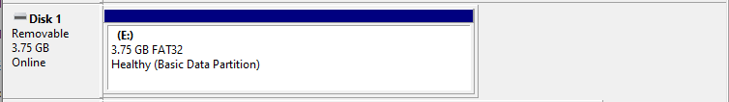

2、Extract the downloaded ZIP file and copy all extracted files directly to the root directory of the USB drive, as shown in the image below.
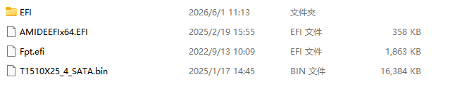

3、Shut down the NAS completely.Remove all hard drives, M.2 SSDs, and the existing TOS boot drive.Please ensure that no storage devices remain installed inside the NAS, then insert the prepared BIOS update USB drive.

4、Connect an HDMI monitor to the NAS, then power it on. After startup, the BIOS update program will run automatically, and the BIOS update information will be displayed on the connected monitor. Once the screen shows the interface illustrated below, it indicates that the system has successfully entered the BIOS update environment and the BIOS update is about to begin.
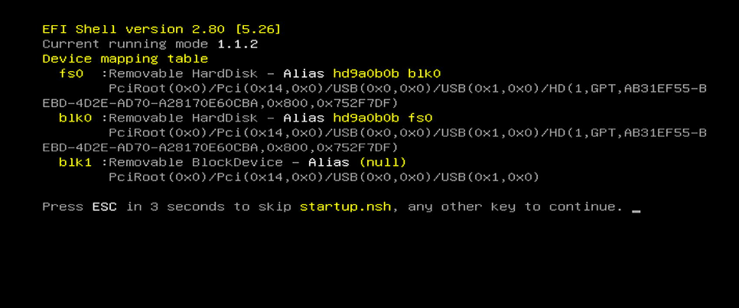
Once the screen shows the completion message as illustrated below, the BIOS update has finished.
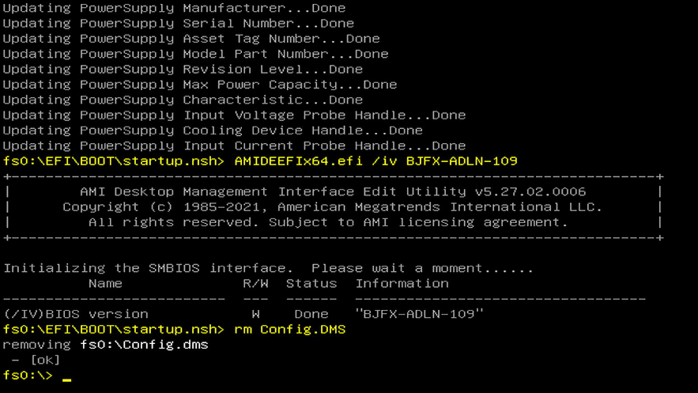
After the BIOS update is complete, please remove the USB drive used for the BIOS upgrade and power on the device again. The system will automatically enter the BIOS Setup interface after startup. Please verify the following information:
- BIOS Version
- Build Date and Time
The expected values should be:
- BIOS Version: T1510X25
- Build Date and Time: 01/17/2025 14:34:21
If the displayed information matches the above values, it indicates that the BIOS update was completed successfully.

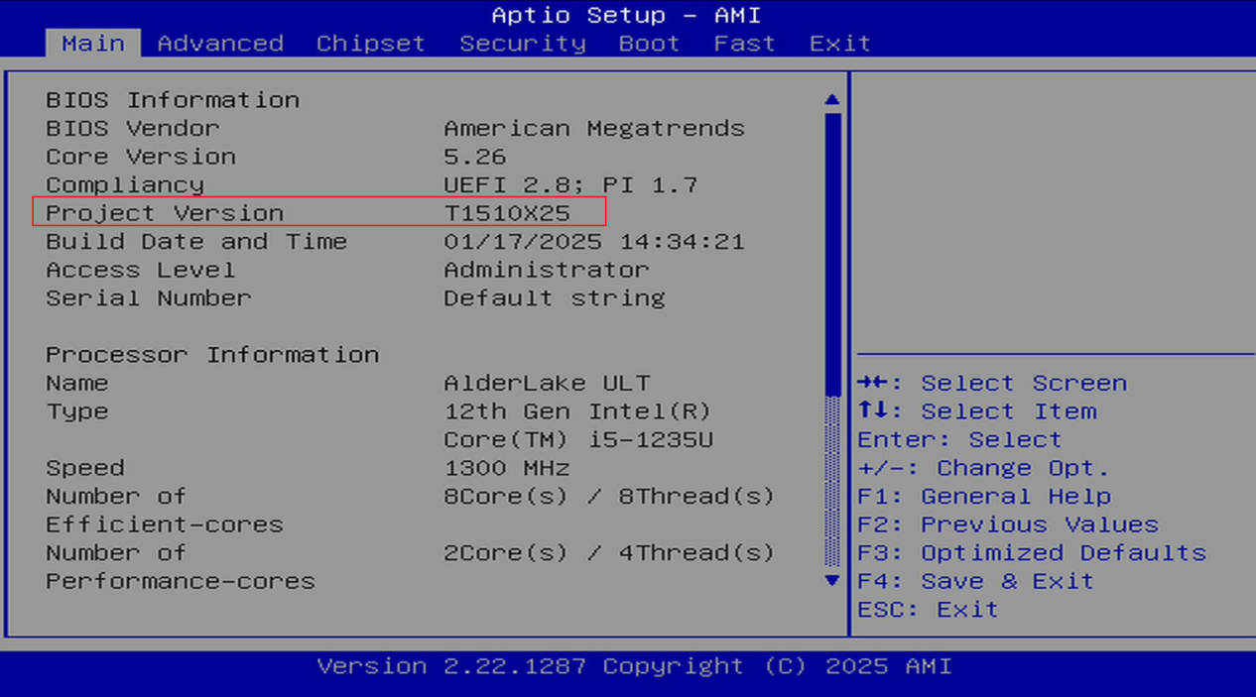

After the BIOS update has been completed successfully, reinstall all hard drives, M.2 SSDs, and the TOS boot USB drive, then power on the NAS.

Guidelines for Modifying Kernel Parameters

Log in to the TOS system via Terminal/SSH and run the following command:
cat /sys/devices/system/cpu/cpuidle/current_driver

If the output is: intel_idle，

please proceed with the following steps.：

Run the following command to check which disk contains the current TOS system:
As shown in the example, if TOS is installed on sdza, you will need to modify the corresponding GRUB boot configuration on that system disk.
Note: If your NAS has two system disks, please apply the same modification to both disks
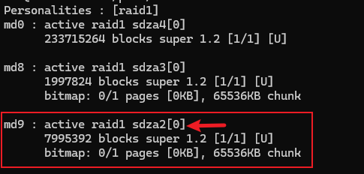
Execute the following command to mount and modify the boot partition parameters on each system disk,
cd /
mkdir a
mount /dev/sdza1 /a/
vim /a/boot/grub/grub.cfg

After entering the boot configuration file in edit mode, add the following kernel parameter to the Linux boot line: intel_idle.max_cstate=1
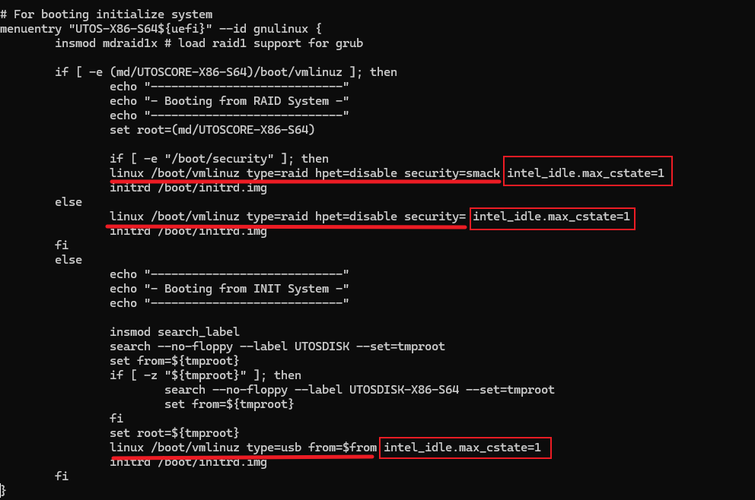
After saving the changes, reboot the NAS: Once the system has restarted, run the following command:
cat /proc/cmdline
Please confirm that the output includes:
intel_idle.max_cstate=1
This indicates that the kernel boot parameter has been applied successfully.
Run the following command:

for c in /sys/devices/system/cpu/cpu[0-9]*; do echo "==================== $(basename $c) ===================="; for s in $c/cpuidle/state*; do echo "$(cat $s/name): usage=$(cat $s/usage), time=$(cat $s/time)"; done; echo; done

If the output shows only shallow idle states such as: POLL or POLL、C1E。and no longer shows deeper states such as C6, C8, or C10, this means the parameter restriction has taken effect successfully.
